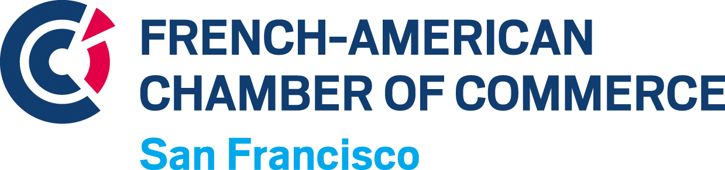

Program Manager
The French-American Chamber of Commerce of San Francisco is looking for a Program manager.
Under the supervision of the Executive Director, the Program Manager will be in charge of supporting the everyday activity of our office and manage the various programs directed to our community of corporates and entrepreneurs.

The FACCSF provides rewarding opportunities to interact with many French and American organizations both private and institutional in a nonprofit environment focused on providing value to businesses in the French-American community.

Responsibilities

Program management:
- Execute membership renewal campaign & follow up.
- Manage and support membership welcoming process, engage with our business community.
- Drive internal projects that leverage our members experience and continue to build member growth.
- Drive the development of our recruitment platform and services.
- Manage trade services programs such as FACCSF’s business center (office & workstation rentals, mailbox subscriptions, etc.).
- Identifying trending and hot topics on the members community to help direct the next program to create.
- Measuring, analyzing, and reporting on membership goals
- Coordinate with the FACCSF communication coordinator and event manager to successfully onboard members.

Admin:
- General administrative duties: maintain a well-organized office space, manage front desk, switchboard, meeting room planning etc.
- Bookkeeping
- Contracts and invoicing management
- Act as go-between with all professional service contacts (phone, internet providers, emailing services, etc.)
- Maintain records, database, ensure filing systems are kept up to date

Requirements:
- Fluency in both spoken and written English and French
- Sales skills, capability of pitching & selling
- Excellent organizational and communication skills
- Detail‐oriented
- Self‐motivated team player with a positive attitude
- Ability to prioritize and work independently
- Adaptability: this is a small size organization, flexibility is a must
- Good computer skills: pack office, Gmail, Google docs, Google calendar, Internet, data base use
- Previous office management experience appreciated
- US work permit

Location: San Francisco, CA 94108
Status: Full-Time
Compensation: 40K

Company Description:
Created in 1978, the FACCSF has 2 principal missions: Serving the needs of the French-American business community, Support of French and American companies with their trade needs. More information: www.faccsf.com

Please send your resume and cover letter at info@faccsf.com

