

MACAW TOURS

**Birding Hike**

Macaw Lodge lies between two different forests rainforests and wet forest. The varied climates, ecologies and terrains support a richness of birdlife that easily exceeds 350 species of migratory and resident birds—including our namesake Scarlet Macaw as well as the Fiery-Billed Aracari, Black-Mandibled Toucan, Orange-Collared Manaquin and Amazon Kingfisher among many others. The birding hike introduces guests to the world of ornithology. A professional guide takes you along paths and trails, helping you locate and identify bird species and shares information about the natural balance of birds in nature.

**Duration:** 2:30 hours (approximately)

**Departure time**: 6:00 a.m. at front desk

**Cost:** $45 per person $ 30 children 7-12 years old

**Recommendations:** Wear comfortable clothes for walking and shoes with good traction. Bring binoculars, camera, water, insect repellent and a poncho if it’s raining.

**This tour must be booked at least 2 days in advance. Minimum: 2 people

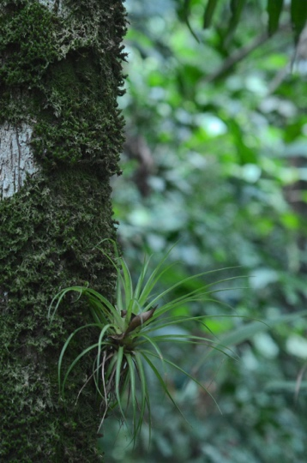**Rainforest Walk**

Macaw Lodge is surrounded by mature forest and tropical rainforest—adjacent to the Carara National Park—offering a diversity of flora and fauna. On your walk you may see a variety of poisonous frogs such as dendrobates auratus; butterflies like the morpho, heliconias; birds including our namesake Scarlet Macaw, owls, toucans and turkeys; mammals such as howler and white face monkeys and many native trees including Ceiba, Nazareno and Lianas.

Duration: 90 minutes

Cost: At no cost the person does it on his own

Recommendations: Wear long pants and shoes with good traction. Bring binoculars, camera, swimsuit, towel, water, insect repellant and a poncho if it’s raining.

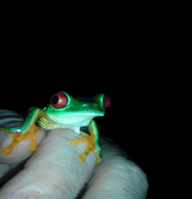**Night Walk**

Located in a rainforest, Macaw Lodge is surrounded by wetlands, ponds and rivers rich with amphibian life. In the cool of the evening, lit by the moon and your flashlight, you are likely to discover an abundance of creatures like the red eyes frog, bullfrog and glass frog, among others, as well as some reptiles.

**Duration:** 90 minutes

**Departure:** 7:30 p.m., from the Lodge reception area

**Cost:** $15 per person no children under 12 years old allowed

**Recommendations:** Wear long pants and shoes with good traction. Bring flashlight, camera (with ability to turn off flash) and insect repellant.

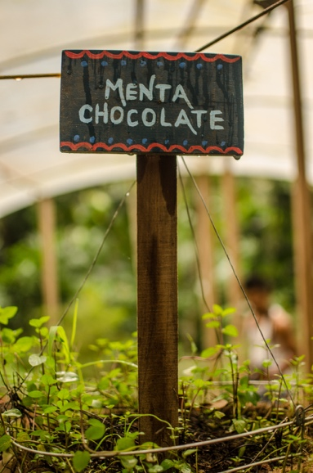**Sustainable Living Tour**

Description: Macaw Lodge is renowned for its environmental commitment and for nurturing its natural surroundings dominated by plantations and crops grown without chemicals. This walk is an opportunity to share in and experience our philosophy of sustainable living.

A knowledgeable guide will lead you in a unique experience exploring our sustainable gardening operations. You will see how we use organic waste, coal and earthworm compost and organic fertilizer; tour our aquaponics orchard where we grow vegetables served to our guests and staff; and see gardens of medicinal plants, used for making teas and ointments.

At the same time you would learn about “Stingless bees “ and it’s valuable honey.

At the end of this walk, you can relax in our Green Corner and discuss what you have learned about the biodiversity of flora and fauna at Macaw. You can also visit our plant nursery and take a sample of this authentic experience.

**Duration:** 90 minutes

**Departure:** 8:30 a.m. and 2:30 p.m., from the Lodge reception area

**Cost:** $25 per person

Recommendations: Wear light and comfortable shoes and clothing, a hat and sun screen. Bring a camera, insect repellent and water.

Must be reserve two weeks at least in advance

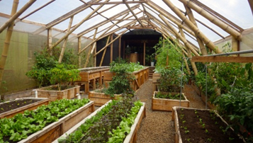 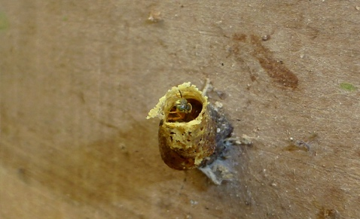

**Exploration of Cocoa—From the Root to the Fruit**

Since ancient times, cocoa has been vital to life in Central America. Mayans invented the basics of preparing cocoa, a process still used today—fermentation, drying and roasting of the beans, then shelling, grinding and milling. People from all levels of society consumed cocoa daily as a beverage. Nobility drank the dark liquid in cups hand-decorated by artists, and it was the favorite drink of Mayan kings and priests.

You’ll see these ancient traditions practiced at Macaw today. The tour takes you through our cocoa plantations to learn about the varieties of cocoa trees, characteristics and the fruit, as well as all that’s involved in the process of bringing this beneficial fruit to the table.

**Duration:** 1:30 hour

**Departure:** 9:00 a.m. or 1:30pm from the front desk

**Cost:** $25 per person

**Minimum:** 2 people (staying at the Lodge)

**Recommendations:** Wear long pants, hat, closed-toe shoes with good traction and sunscreen. Bring a camera and water.

This tour can also be done as a day trip from San Jose or Jaco (minimum of 4 people and a reservation required at least 3 days in advance).

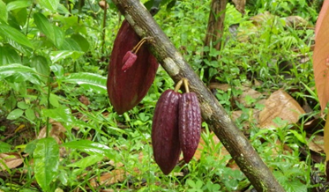 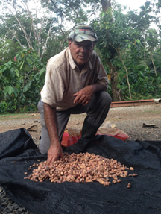

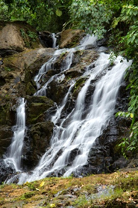**Waterfall Trail**

During the last 60 years, the Turrubares region underwent intensive deforestation to clear the way for agricultural crops and pastures. As a consequence, the region experienced the devastation of erosion and depletion of soil nutrients, ultimately resulting in diminished health and social conditions for humans as well as flora and fauna. The few areas left with healthy forests became shrines and home to a decreasing variety of wildlife, plant species and water sources. Amid this regional chaos, the Macaw Lodge Private Reserve was lovingly nurtured into an oasis of biodiversity. The Reserve spans 100 hectares (247 acres) between dry and humid forests, entirely dedicated to the preservation of its rich natural diversity and ancient history. The trail to the waterfall winds 800 meters (approximately one half mile) through the deep forest, to explore plants, animals, history and scenic beauty. Your walk is rewarded with time to take a refreshing dip and play in the waterfalls.

**Duration:** 1 hour

**Cost:** Free the person does it on his own

**Recommendations:** Wear long pants, a swimsuit and shoes with good traction. Bring water shoes if you wish, towel, binoculars, camera, water, insect repellent, sun screen and a poncho if it’s raining.

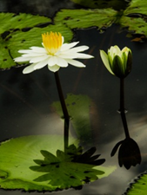**Botanical Garden Tour**

Our Lodge was built in the middle of a botanical garden that covers 5 hectares (nearly 12-1/2 acres). This garden is a collection of more than 500 species of ornamental, medicinal and food plants from around the world. These gardens are divided into a mosaic of colorful plots that lie between natural ponds and streams. Palms, bromeliads, fruit trees, cacti, bamboo, lilies, heliconias and many others cover the earth like a multi-hued carpet. The guided walk follows a path that crosses the gardens and offers opportunities to learn about the wonderful world of plants and their relationship with humans in the natural environment.

**Duration:** 2 hours

**Cost:** Free the person does it on his own

**Recommendations:** Wear light and comfortable shoes, a hat, insect repellent and sun screen. Bring a camera, binoculars and water.

**Optional Excursions Arranged by Macaw Lodge**

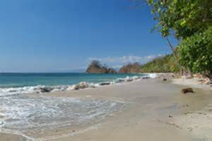**Playa Blanca**

Playa Blanca (White Beach), a beautiful white beach along emerald waters, is part of an area of 300 hectares (741 acres) of lush tropical forest. It is located in Punta Leona near Jaco, 45 minutes from Macaw Lodge. It is perfect for lovers of sun and nature, and a safe place to swim. Snorkeling (when conditions permit) and outriggers are optional for an additional cost.

**Cost:** no entry fee for Macaw guests. Excursion does not include transportation from and to Macaw Lodge. Please ask at reception about transportation options and cost.

**Recommendations:** Bring hat, sun screen, sandals, bathing suit, beach towel, a change of clothes, water and insect repellent.

**Kayak 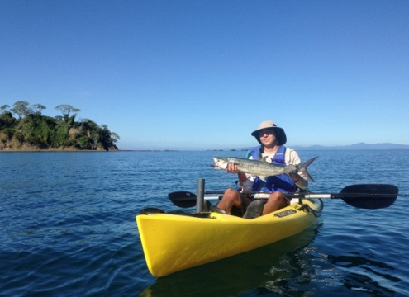Fishing**

Kayak Fishing is offshore fishing at its best.   The kayak was originally created by the Eskimos for fishing. It is quiet, fast, lightweight, stable and sea worthy.  It just might be the safest and easiest way to get you off the beach and out to the fish.  Every fish on the line is exciting in a kayak.   
     
You will fish the waters of the Gulf of Nicoya near Playa Agujas for 3 hours and hopefully hook the catch of your dreams.  We only guarantee the fishing— the catching is up to you.  The water is warm and the scenery spectacular.  
  
All equipment is provided and we regularly catch, Bonita, Corvina, Grouper, Mackerel, Jacks, Roosterfish and Snapper.

**Departures:** 8:10 a.m. and 1:40 p.m. from Herradura.

Tour cost based on number of people. Quote provided on request.

**Transportation:** Available from Jaco and surrounding areas at an additional cost. Also available from Macaw Lodge, cost based on number of people. Please ask at reception.

**Details:** Great guides, all necessary equipment, bottled water, a fresh fruit buffet on the beach, showers and changing rooms after the tour along with a cold drink are provided.

**Recommendations:** Bring hat, sun screen, water shoes, bathing suit, change of clothes and a towel. Dry bags are available.

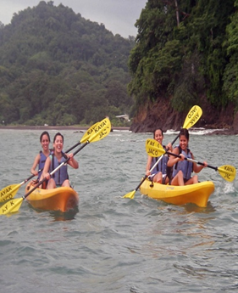**Sea Kayaking and Snorkeling**

This Sea Kayaking and Snorkeling tour is serious fun. This tour operator has been leading sea adventures since 1997 and it just keeps getting better. No experience is necessary to enjoy the spectacular scenery. Distances and destinations are suitable for all experience/skill levels.

The equipment is top notch and easy to paddle with lightweight bamboo paddles. Snorkeling (when conditions permit) is from the beach so there are lots of other options if someone in the group is into monkey and bird watching or beachcombing.

Departures: Half-day tour departs from the paddling center in Playa Agujas at 8.10 a.m. and 1:40 p.m. Reservations required.

**Duration:** Approximately 3 hours, 4 with transport from Jaco

**Tour cost based number of people. Quote provided on request.**

**Transportation:** Available from Jaco and surrounding areas at an additional cost. Also available from Macaw Lodge, cost based on number of people. Please ask **at reception.**

**Details:** Great guides, all necessary equipment, bottled water, fresh fruit buffet on the beach, showers and changing rooms after the tour along with a cold drink are provided. Perfect for active independent travelers and families, and small groups up to 16 paddlers.

**Recommendations:** Bring hat, sun screen, water shoes, bathing suit, change of clothes and a towel for after. Dry bags available.

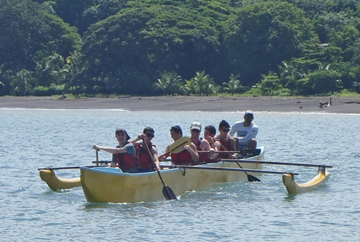

**Outrigger Canoe and Snorkeling Tour**

Description: This half-day outrigger canoe tour is unique to Costa Rica. Pioneering the use of outrigger canoes (Hawaiian style canoes), we provide a fun way to take groups on the ocean.

The outriggers are a great equalizer of abilities. The steersperson in the canoe takes care of controlling your direction and all outriggers reach the most beautiful beaches around at the same time. The canoes are more efficient than kayaks, and paddling is a little easier. You will glide past spectacular cliffs covered with frigate birds and pelicans. Your guide will point out interesting landmarks.

We snorkel (when conditions permit) from the beach so there are many other options if someone in the group is into monkey and bird watching or beachcombing. No experience is necessary to enjoy this tour to the fullest.

**Departures:** Half-day tour departing from the paddling center in Playa Agujas at 8.10 a.m. and 1:40 p.m. Reservations required.

Duration: Approximately 3 hours, 4 with transport from Jaco.

Tour cost based number of people. Quote provided on request.

**Transportation:** Available from Jaco and surrounding areas at an additional cost. Also available from Macaw Lodge, cost based on number of people. Please ask at reception.

**Details:** Great guides, all necessary equipment, bottled water, fresh fruit buffet on the beach, showers and changing rooms after the tour along with a cold drink are provided. Perfect for active independent travelers and families, and small groups up to 16 paddlers.

Recommendations: Bring hat, sun screen, water shoes, bathing suit, change of clothes and a towel for after. Dry bags available.

This tour is perfect for larger groups, up to 40 paddlers, families with small kids or older adults, and for high school, university and corporate activities. There’s also a multi-sport tour option. We can operate the tour with a minimum of 4 persons.

**Recommendations:** Bring hat, sun screen, water shoes, bathing suit, change of clothes and a towel for after. Dry bags are available.