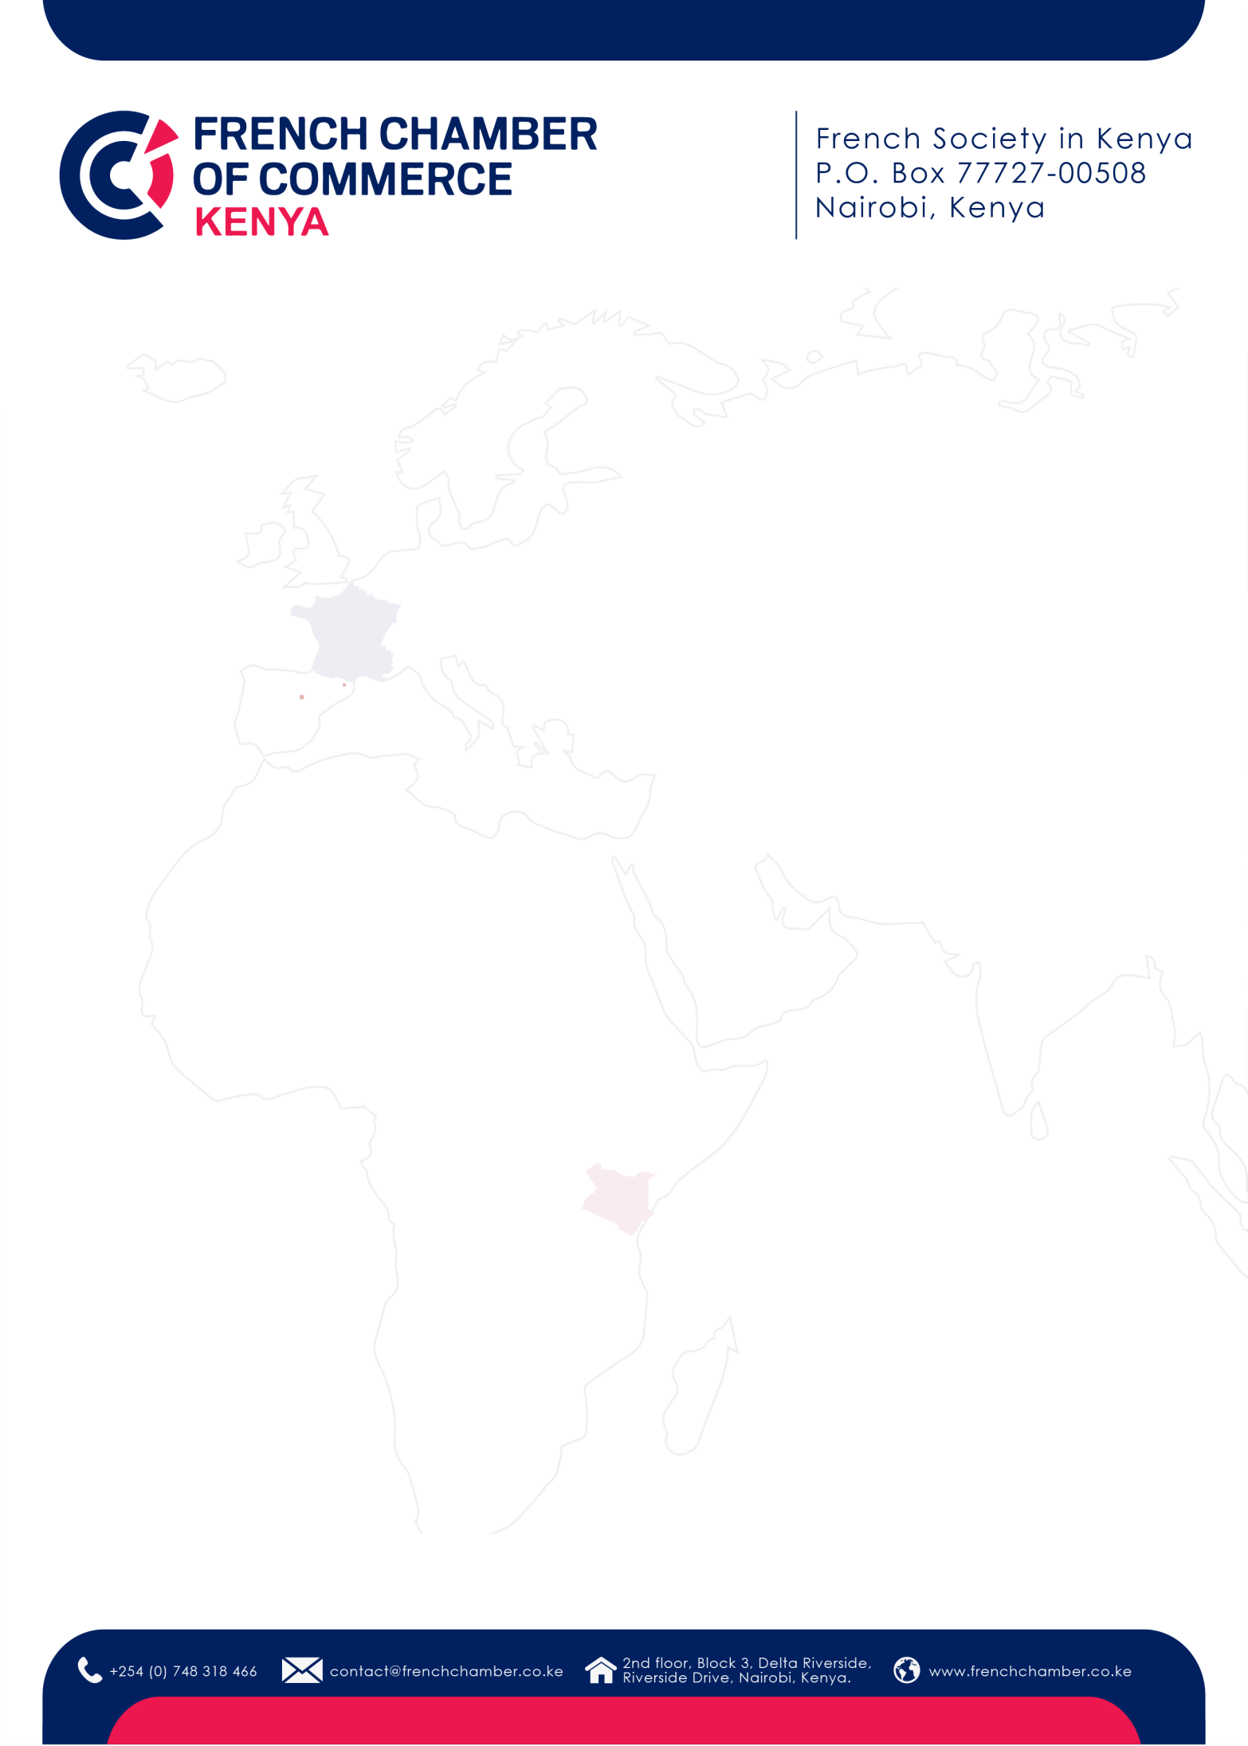

1

**REGISTRATION FORM**

**/**

**Welcome to the French Chamber of Commerce in Kenya!**

**Please fill out th**

**is**

**registration form to**

**finalize your membership process.**

**M**

**embership category**

**please indicate the category you have selected**

**)**

**(**

**Company**

**/ Organization**

**information**

Company name

:

Address

:

Phone number:

KRA Pin:

Website

:

**Main contact**

First name & name

:

Position

:

Email

:

Phone number

:

**CEO / Top Management contact**

First name &

name

:

Position

:

Email

:

Phone number

:

**CFO / Finance & Accounting contact**

First name & name

:

Position

:

Email

:



2

Phone number

:

**Communications & Partnerships contact**

First name & name

:

Position

:

Email

:

Phone number

:

**HR contact**

First name & name

:

Position

:

Email

:

Phone number

:

**Any other contact you would like us to add to our mailing list?**

First name & name

:

Position

:

Email

:

Phone number

:

**Member Agreement**

A

greement to become a member

□

Yes

□

No

Agreement to receive the French Chamber’s communications by email

□

Yes

□

No

Date

Signature and stamp

of the company / organization