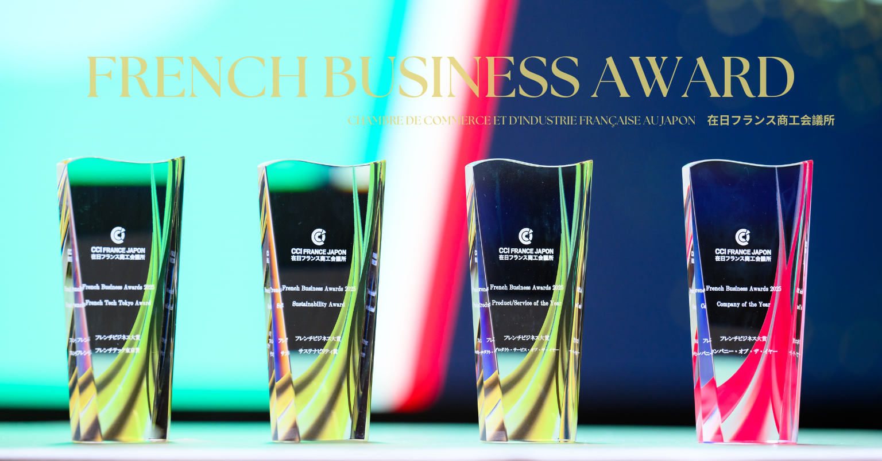

FRENCH BUSINESS AWARDS 2026
Application Form

SUSTAINABILITY AWARD

About the award
This award recognizes companies or SMEs that are members of the French Chamber and have demonstrated excellence and outstanding achievements in their operations with France and/or Japan during 2024-2025. To apply, please complete this form in English (unless specified otherwise) with as much accuracy and detail as possible.
Your company must be a member of the French Chamber of Commerce and Industry in Japan to apply for this category.
The deadline for the submission of your application is Friday, January 9th, 2026 at 17:00 (Tokyo).

Please submit your completed application promptly, as spots are limited for each category.
Please note that the Jury will sign a confidentiality agreement. No information, data, or figures will be shared with third parties without your explicit authorization.

_________________________________________________________________
SECTION 1: About Your Company
_________________________________________________________________

General information:

Company name (Alphabet): ___________________________________________

Company name (Japanese): ___________________________________________

Website: ___________________________________________

Date of creation or beginning of operation in Japan: ______________________

Is your company a subsidiary of a large group / corporation? Yes / No

If you answered ‘Yes’, what is the country of origin of your company? ________________

President / Managing Director’s name and title (alphabet and Japanese): _________________________________________________________________________

____________________________________

Main contact for the contest:

Name (Alphabet and Japanese): ___________________________________________

Title (Alphabet and Japanese): ___________________________________________

Email: ___________________________________________

Tel.: ___________________________________________

_______________________________________________________________

SECTION 2: Main Activities Summary (English)
_________________________________________________________________

Please provide a brief summary of your main activities in English. This summary will be used for press releases after the event and will assist the jury in making their decision. Your summary should include essential details about your business and the products or services you offer or plan to offer.

English Summary
700 characters max. Spaces included

_________________________________________________________________________

_________________________________________________________________________

_________________________________________________________________________

_________________________________________________________________________

_________________________________________________________________________

_________________________________________________________________________

_________________________________________________________________________

_______________________________________________________________

SECTION 3: Company’s short and long-term project, development strategy
________________________________________________________________

Please provide a brief overview of your company’s current projects and future plans. Include key goals, development strategies, and any initiatives that will support your growth.

_________________________________________________________________________

_________________________________________________________________________

_________________________________________________________________________

_________________________________________________________________________

_______________________________________________________________

SECTION 4: Company’s Growth and Financial Performance in Japan
________________________________________________________________

Please present the growth and development of your company in Japan. Providing your financial data will give the Jury a clearer understanding of your company’s performance and operations in Japan. If the figures are confidential, you may omit this section.

2024 turnover
What was your company's turnover (in JPY)?

___________________________

2024 workforce:
How many employees worked at your company as of 2023?

___________________________

2025 turnover (forecast):
What is your company's turnover (in JPY)?

___________________________

2025 workforce (forecast):
How many employees work at your company as of today?

___________________________

________________________________________________________________

SECTION 5: Why Our Company Deserves to Win
________________________________________________________________

Why Our Company Deserves This Award? (1000 characters maximum)

Please explain why your company deserves this Award. The Jury will consider the following criteria:

- Clear explanation of your overall business and demonstrable growth or measurable results.
- Proven commitment to customers.
- Excellent record in staff training and personal development.
- Stimulating and supportive workplace.
- Advancement of diversity, equality of opportunity, fairness, and gender equality in all activities.
- Demonstration of high ethical standards.
- Strategic application of business processes and operations.

_________________________________________________________________________

_________________________________________________________________________

_________________________________________________________________________

_________________________________________________________________________

_________________________________________________________________________

_________________________________________________________________________

_________________________________________________________________________

_________________________________________________________________________

_________________________________________________________________________

_________________________________________________________________________

_________________________________________________________________________

_________________________________________________________________________

_________________________________________________________________________

_________________________________________________________________________

_________________________________________________________________________

_________________________________________________________________________

_________________________________________________________________________

_________________________________________________________________________

____________________ ____________________
Name of the applicant Date

Additional information:

Once you have completed all the mandatory sections of the form, you are welcome to include any additional information that you believe will strengthen your application. This could be in the form of a press book, preferably in English or French. Please ensure that the information you submit is concise and comprehensive, as hyperlinks will not be accepted. Your submission will be presented to the Jury exactly as received, so please take care to prepare your documents thoroughly. We recommend combining, editing, or expanding the publicity brochures you already use.

Please send us along with this form the logo of your company in high definition with a transparent background, preferably in .ai or pdf format.

Application forms should be returned by e-mail to:

Hikaru OSHIRO, Events Officer
h.oshiro@ccifj.or.jp

The deadline for the submission of your application is Friday, January 9th, 2026 at 17:00 (Tokyo).

For further information:
Hikaru OSHIRO, Events Officer (French/ English/ Japanese)
E-mail: h.oshiro@ccifj.or.jp

