Uncorked Cinq & Bubbles
A Champagne-Paired Culinary Journey with Bollinger

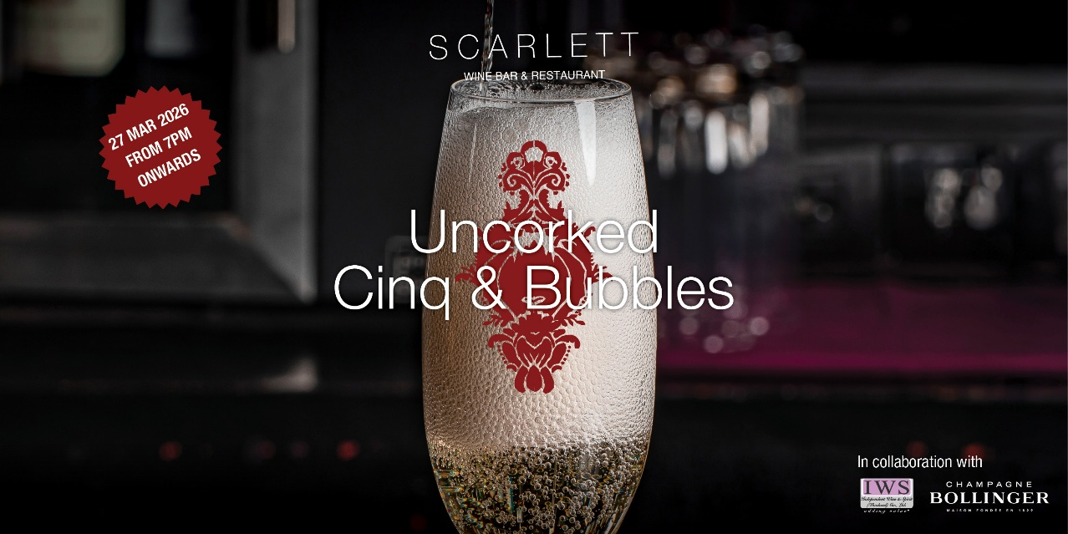

Download photo click

On 27 March 2026 from 7:00 PM onwards, step into an evening of great food and iconic Champagne with Uncorked Cinq & Bubbles.

This one-night dining experience brings together a beautifully curated four-course menu paired with Bollinger Champagne, inspired by the historic village of Aÿ, France — the home of the legendary Champagne house.

Created for those who love good food and great bubbles, the evening pairs thoughtfully crafted dishes with Bollinger’s signature cuvées, each one selected to complement the flavors on the plate. Expect a progression of seasonal ingredients, elegant seafood, rich textures, and a vibrant dessert finish — all designed to highlight the character and depth of every pour.

Date:27 March 2026
Time:7:00 PM onwards
Price: THB 4,900++ per person
Four-course menu with Champagne pairing

The Menu & Pairings:
Bollinger Special Cuvée
Gillardeau No.5 oyster
Combava gel, cucumber pearls

Bollinger PN VZ19
Roasted langoustine
Roasted parsnip, walnut emulsion, cédrat zest

Bollinger Special Cuvée
Roasted scallop
Jerusalem artichoke mousseline, reduced apple jus

Bollinger La Grande Année 2015
Roasted yellow chicken
Morel mushrooms, baby spinach

Bollinger Rosé 2006
Hibiscus strawberry
Candied rhubarb, buckwheat sable

Reservation please call 096 860 7990, message the restaurant on LINE (@scarlettbangkok) for more details or make a reservation via Sevenrooms.

-ends-

About Scarlett Wine Bar & Restaurant
With exquisite French cuisine, creative cocktails, a great wine list and panoramic views of Bangkok’s skyline, Scarlett Wine Bar and Restaurant promises a memorable rooftop dining experience. The Michelin-recommended rooftop bar and French restaurant in Bangkok boasts a produce-driven menu, featuring smaller tapas-style bites as well as charcuterie and cheese boards, succulent dry-aged steaks, fresh seafood grill and more, served in a lively and sophisticated ambience. Scarlett’s elegantly designed space is sleek and inviting yet unpretentious, making it a great choice for any occasion. Guests can choose to dine alfresco at the terrace or in air-conditioned comfort at the stylish restaurant and bar.
About R&B Lab
With over two decades in the food and beverage sector in Asia, Europe and the USA, R&B Lab has been dedicated to creating, launching, and running experience-driven restaurants and bars, designed to be cutting-edge, high-yielding and long-term. R&B Lab curates distinct dining experiences that celebrate quality ingredients and enhanced special moments. Always pushing boundaries, R&B Lab’s dynamic portfolio continues to expand globally, with over 10 cutting-edge venues under its helm.
Media Contact
Supatthra Ambua (Ma’miew)
Senior Marketing Manager
188 SILOM ROAD, BANGRAK, BANGKOK 10500 – THAILAND
T. +66 (0) 2352 4000 – M. +66 (0) 84 6372865
SUPATTHRA@PULLMANBANGKOKHOTELG.COM

