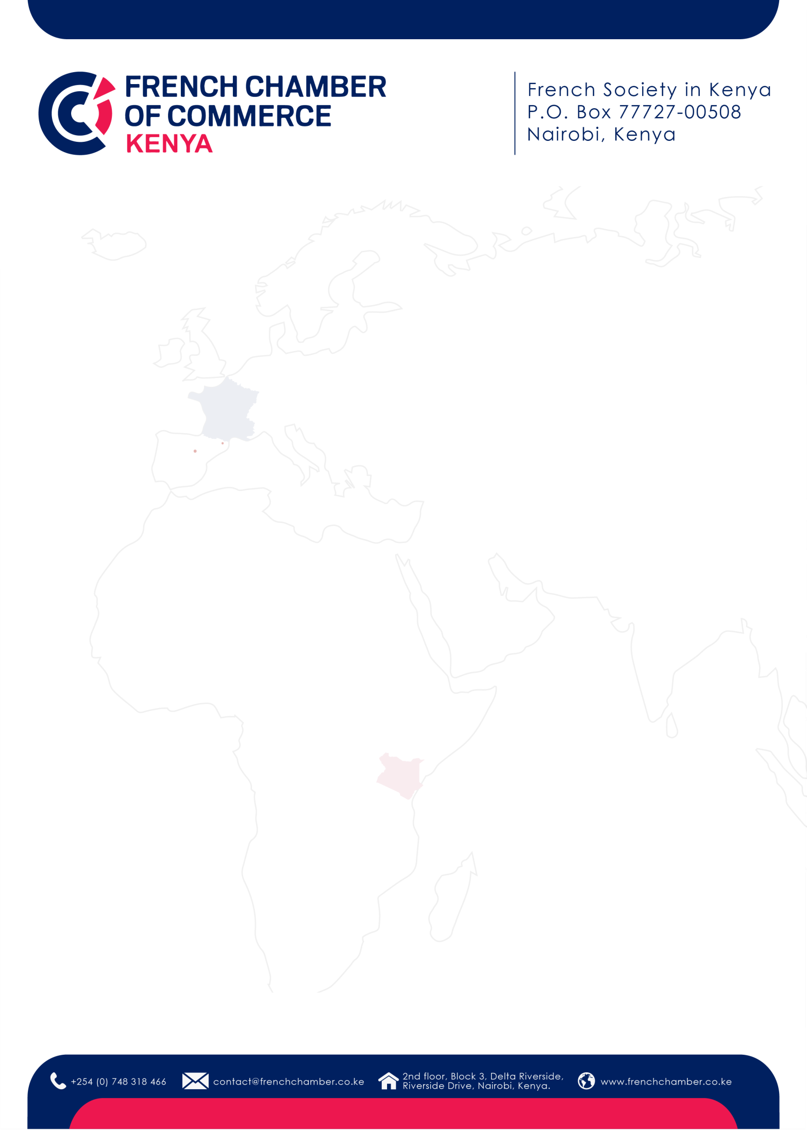

1

REGISTRATION FORM

/
Welcome to the French Chamber of Commerce in Kenya!
Please fill out th
is

registration form to
finalize your membership process.

M
embership category

please indicate the category you have selected
)
(

Company
/ Organization
information

Company name
:

Address
:

Phone number:

KRA Pin:

Website
:

Main contact

First name & name
:

Position
:

Email
:

Phone number
:

CEO / Top Management contact

First name &
name
:

Position
:

Email
:

Phone number
:

CFO / Finance & Accounting contact

First name & name
:

Position
:

Email
:

2

Phone number
:

Communications & Partnerships contact

First name & name
:

Position
:

Email
:

Phone number
:

HR contact

First name & name
:

Position
:

Email
:

Phone number
:

Any other contact you would like us to add to our mailing list?

First name & name
:

Position
:

Email
:

Phone number
:

Member Agreement

A
greement to become a member

□
Yes
□

No

Agreement to receive the French Chamber’s communications by email
□
Yes
□

No

Date

Signature and stamp

of the company / organization

