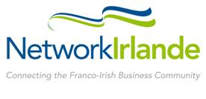
Ireland France
Business Awards 2016
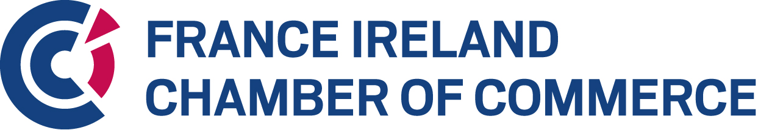

Special Jury’s Award for Impact on Climate Change
ENTRY FORM

Company Details

Name of Company _______________________________________________________________
Address______________________________________________________________________________________________________________________________________________________________________________________________________________________________________
Country of Registration ______ Ireland _____________ France ________________
Name of CEO ___________________________________________________________________
Contact for the Awards ___________________________________________________________
Position ________________________________________________________________________
Telephone ___________________________Email______________________________________
Website ________________________________________________________________________

Business Profile
Describe your business in general. Include information on annual turnover, profit, and employees in the last two years (2014 & 2015) and projecting to 2016. Include information on your company’s activities in both Ireland and France (300 words)

Sustainable business practices

- Provide an overview of your company’s sustainable strategies, with the focus on those you excel in, such as energy efficiency, clean energy opportunities, GHG reduction goals, engaging supply chains, and other practical applications for measuring, managing and reducing emission.
Also demonstrate how these strategies align with the “Sustainable Development Goals”. Refer to practices in both France and Ireland. (300 words)

Innovation leading to climate change
Describe your company’s implementation of innovative solutions or methodologies or creation of new knowledge around climate change. Demonstrate how these innovations align with “best practice”.
Explain how this innovation addresses major environmental issues. (300 words)

Emerging best practices on climate resilience / adaptation planning and implementation
- Describe how your company’s sustainable business strategy is a positive input to emerging best practices. Focus on what differentiates your company, and qualifies you to win the award for “Impact on Climate Change” in the Irish-Franco business context. (300 words)
Please return completed Entry Form to info@franceireland.ie
All information received will be treated in confidence.
Companies who do not provide all the information on this entry form, including financial figures, will be excluded.
If you wish to include more information with your application, you may send this on-line as additional material. However please be aware that the content of the Entry Form will be the key content by which your application will be judged.
Thank you for your nomination. Award recipients shall be selected by a jury in a 2-step Evaluation process, chaired by Mr Gerry Halpenny, Senior Partner of LK Shields.

