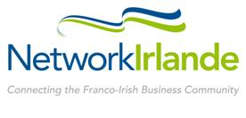
Ireland France
Business Awards 2016
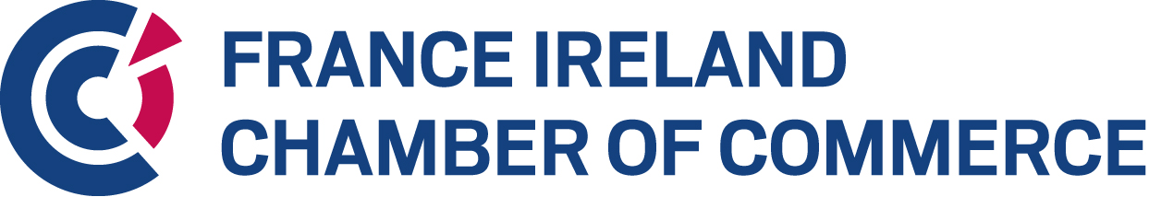

The annual Franco-Irish Business Awards recognising excellence in the economic relationship between Ireland and France
ENTRY FORM

Company Details

Name of Company _______________________________________________________________
Address______________________________________________________________________________________________________________________________________________________________________________________________________________________________________
Country of Registration ______ Ireland _____________ France ________________
Name of CEO ___________________________________________________________________
Contact for the Awards ___________________________________________________________
Position ________________________________________________________________________
Telephone ___________________________Email______________________________________
Website ________________________________________________________________________
Category you are applying for:
Best Irish Company in France
Best French Company in Ireland

Business Profile
Describe your business in general. Include information on annual turnover, profit, and employees in the last two years (2014 & 2015) and projecting to 2016. (200 words)

Financial Success

- Demonstrate the overall growth in sales/profitability, and development of business activity in France or Ireland and linked to the French/Irish market (Years 2014, 2015 and projected 2016) (100 words)

- Indicate level of investment committed to the market of destination (employees, external consultants, office space....) (100 words)

Innovation
Describe the unique selling proposition of your product/service that has secured your success on the Irish or French market (200 words)

Employment – Current & Future
- Present the employment strategy of your company into the future, supported by employment figures in Ireland and France, and a general overview of the employment policy (200 words)

- Demonstration that the company is a high quality employer (working environment, employment benefits, HR management) (100 words)

- Demonstration that the employment between Ireland & France has increased positively from the viewpoint of both countries (100 words)
Please return completed Entry Form to info@franceireland.ie
All information received will be treated in confidence.
Companies who do not provide all the information on this entry form, including financial figures, will be excluded.
If you wish to include more information with your application, you may send this on-line as additional material. However please be aware that the content of the Entry Form will be the key content by which your application will be judged.
Thank you for your nomination. Award recipients shall be selected by a jury in a 2-step Evaluation process, chaired by Mr Gerry Halpenny, Senior Partner of LK Shields.

Corporate Social Responsibility

Describe your Company's commitment to CSR (200 words)

